
STUDENT CASE STUDY EXECUTION REPORT
Department | FED
Subject | DSA-2
Academic Year | I-III Semester (2025-26)
Faculty Name | G.Mamtha
Student Name | K.Hemanth
Roll Number | 2520030230
Branch | CSE
Course Outcome | CO3

Case Study Topic: EventSphere Venue Connectivity Optimization using Kruskal MST
Work Done Summary:
The application of graph algorithms and Minimum Spanning Trees in venue connectivity optimization. A Venue Connectivity System was developed where event venues are connected with minimum infrastructure cost using Kruskal's Algorithm.
Implementation Details:
- Created Edge class with source, destination, and weight.
- Created Graph representation.
- Stored venue connectivity information.
- Sorted edges according to cost.
- Implemented Union-Find structure.
- Applied Kruskal MST algorithm.
- Avoided cycle formation.
- Selected minimum-cost edges.
- Generated MST report.
- Main method demonstrated venue network optimization.
Result Screenshots/ Output:
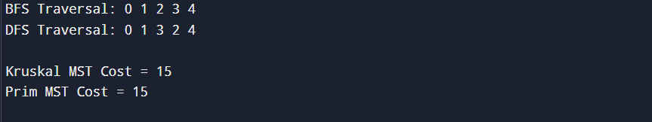

Time Complexity Analysis:
- Graph Creation: O(E)
- Where E is the number of edges (connections between venues).
- Edge Sorting (Kruskal's Algorithm): O(E log E)
- All edges are sorted in ascending order of weight before MST construction.
  - Union-Find Operations: O(α(V))
- Nearly constant time due to Path Compression.
- Where V is the number of vertices (venues).
  - Kruskal's MST Algorithm: O(E log E)
- Dominated by edge sorting operation.
  - DFS Traversal: O(V + E)
- Visits every vertex and edge exactly once.
  - BFS Traversal: O(V + E)
- Explores all vertices and edges level by level.

GitHub Link:https://github.com/hemanthkasani25-web/DSA_2
Student Signature | Faculty Signature

